
NOTE: This is an official document by Indexademics. Unless otherwise stated, this document may not be accredited to individuals or groups other than the club IDX, nor should this document be distributed, sold, or modified for personal use in any way.
IDX G9 Geometry S+ STUDY GUIDE ISSUE 7
By Aiden and Julie

Contents:

- 6-1 Circles and Arcs
- 6-2 Chords and Arcs
- 6-3 Inscribed Angles
- 6-4 Tangent lines
- 6-5 Angles Measures and Segment Lengths
- 6-6 Areas of Circles and Sectors

- 6-1 Circles and Arcs
- New term
·Central angle
A central angle is an angle whose vertex is the center of the circle.
·Arc
An arc is a part of a circle.
·Semicircle
A semicircle is half of a circle.
·Minor arc/Major arc
A minor arc/major arc is smaller/greater than a semicircle.
·Measure of an arc
The measure of an arc is equal to the degree of its central angle in measurement.
Or the measure of a semicircle is 180. The measure of a minor arc is the measure of its corresponding central angle. The measure of a major arc is 360 minus the measure of its related minor arc.
- New Postulate/Theorem
Postulate 10-1 (Arc Addition Postulate) The measure of the arc formed by two adjacent arcs is the sum of the measures of the two arcs just mAC=mAB+mBC
Theorem 10-9 (Circumference of a circle) The circumference of a circle C=πd=2πr.
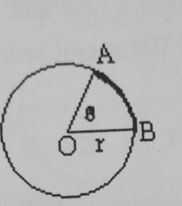
Theorem 10-10 (Arc Length) The length of an arc of a circle is the product of the ratio $\frac{θ}{360}$ and the circumference of the circle, just length of AB = $\frac{2θπr}{360}$

- 9-2 Chords and Arcs
- New Term
·Chord
A chord is a straight line segment whose endpoints both lie on a circle.
- New Theorem
Theorem 12-4
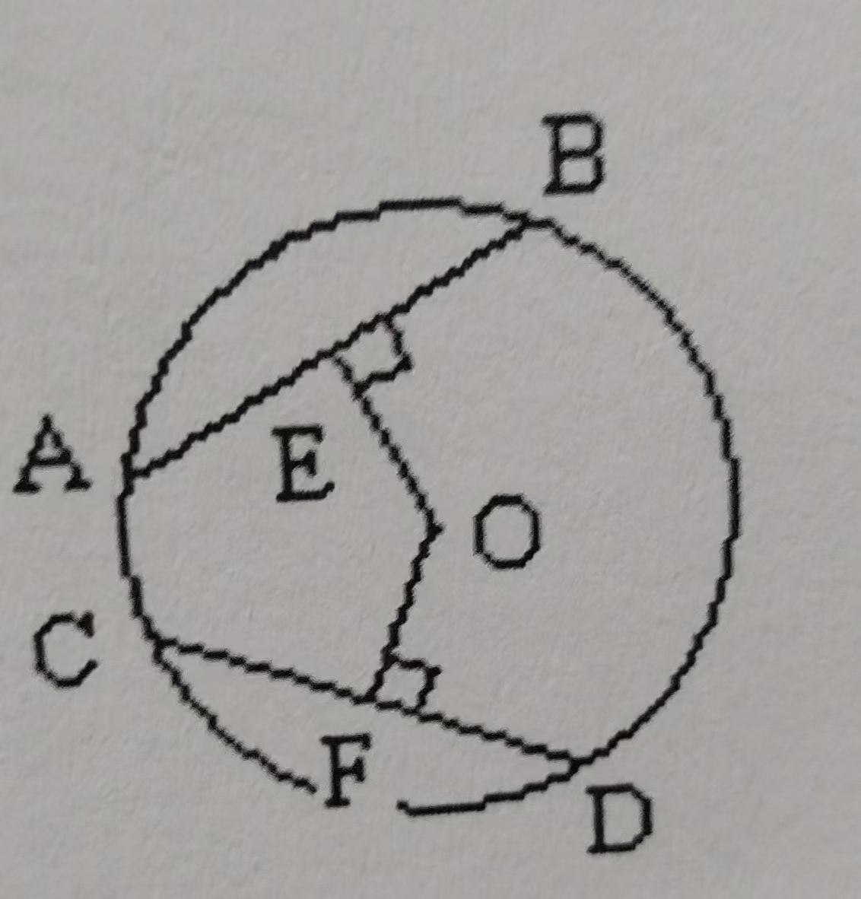
Within a circle or in congruent circles, congruent central angles also have congruent chords and congruent arcs.
Theorem 12-5
Within a circle or in congruent circles, Chords equidistant from the center are congruent. Congruent chords are equidistant form the center. Just OE=OF, AB=CD
Theorem 12-6 In a circle, a diameter that is perpendicular to a chord bisect the
chord and its arcs.
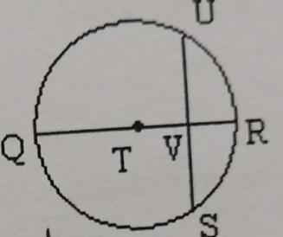
Theorem 12-7 In a circle, a diameter that bisects the chord (that is not a diameter)
is perpendicular to the chord.
Theorem 12-8 In a circle, the perpendicular bisector of a chord contains the diameter the circle.

- 6-3 Inscribed Angles
Key Definitions
• Inscribed Angle: An angle whose vertex lies on the circle, and its sides are chords of the circle.
• Intercepted Arc: The arc that lies in the interior of an inscribed angle, with endpoints at the angle’s sides.

Theorem 12-9: Inscribed Angle Theorem
• Statement: The measure of an inscribed angle is half the measure of its intercepted arc.
Formula: angle1= 1/2 angle1’s arc
Corollary 1: Two inscribed angles that intercept the same arc are equal.
Corollary 2: An angle inscribed in a semicircle is a right angle (90°).
Theorem 12-10: Tangent-Chord Angle Theorem
• Statement: The measure of an angle formed by a tangent and a chord through the point of tangency is half the measure of the intercepted arc.
Formula: angle1= 1/2 angle1’s arc
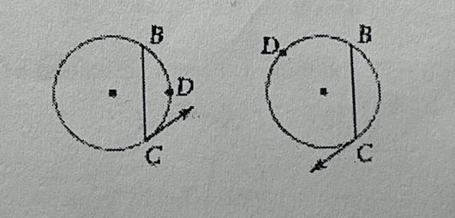

- 6-4 Tangent lines
Key Definitions:
• Tangent line to a circle: A line that intersects the circle at exactly one point (called the point of tangency).
• If a line is tangent to a circle, it is perpendicular to the radius at the point of tangency.

Theorem 12-1:
If a line is tangent to a circle, then it is perpendicular to the radius at the point of tangency.

Converse of Theorem 12-1:
If a line in the plane of a circle is perpendicular to a radius at its endpoint on the circle, then the line is tangent to the circle.

Theorem 12-3:
Two segments tangent to a circle from a point outside the circle are congruent.

- 6-5 Angles Measures and Segment Lengths
- New Theorem
Theorem 12-11 The measure of an angle formed by two lines that
- Intersect inside a circle is half the sum of the measures of the intercepted arcs, just m$∠1=\frac{x°+y°}{2}$
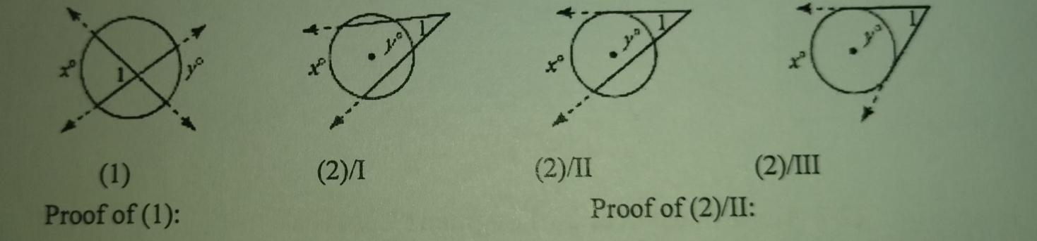
- Intersect outside a circle is half the difference of the of the measures of the intercepted arcs, just m∠1=$\frac{x°-y°}{2}$

Theorem 12-12 For a given point and circle, the product of the lengths of the two segment from the point to the circle is constant along any line through the point and circle.

- 6-6 Areas of Circles and Sectors
- New Theorem
Theorem 10-11 (Area of a Circle) A=$πr^{2}$
Theorem 10-12 (Area of a Sector of a Circle) Area of sector AOB = $\frac{θπr^{2}}{360}$, where $θ=m∠AOB$

